MeJA experiment

## Harvesting （8月13日， after dinner）

I sprayed two cultivars of tea plants with MeJA or control solution (water). For each of the four treatments, we will pick all the young shoots (two leaves and one bud) in three groups. For example, for the 龙井 that was sprayed with MeJA, the left third of the plants will be collected in one bag, the middle third in another bag, and the right third in a third bag. Hopefully the fresh weight of tea leaves in each bag will be about 50g or more. Then for 萎凋we will spread the leaves out on bamboo trays overnight.

## Processing （8月14日， 早上）

绿茶：For each sample, half of the leaves will be made into green tea by using a microwave oven to do 杀青。Usually I just microwave the tea for about 2 minutes on medium power. Then we will dry the leaves.

乌龙茶：The other half of the leaves will be processed as oolong. We will do 摇青 by shaking the leaves in a basket.

Previously, I did this by shaking for 10 minutes, then letting the leaves rest for 45 minutes and repeating this 3 times. We will have to do it differently this time because there will be many more samples. I don’t know the best way to do this yet. Maybe we only shake each sample for 5 minutes, or maybe we can use the shaking machine we brought with us. We will have to figure it out together. After 摇青 we will do 杀青 the same way as with the green tea.

Drying: There are machines in the lab to dry the tea. Li Xin told me to set it to about 80ºC and high air flow to do the drying. I’m not sure how long it will take.

小绿叶蝉 experiment （8月16日？17日？）

I will check the damage on the leaves each day and decide to end the experiment when the high density samples have enough damage. When the experiment is finished we will have to do a lot of work.

## 1. Counting leafhoppers

We will try to count the number of leafhoppers still alive in each bag. While we count them, we can try to catch them to use again in future experiments, but it’s ok if we don’t catch them all.

## 2. Collecting volatile chemicals

Wei Ji Peng has told you that I use something called a “Twister” to measure volatiles. Twisters are a small magnet coated with a plastic called PDMS. PDMS absorbs volatile chemicals. We will put them on one leaf in each bag using two small magnets on the other side of the leaf. Here’s a picture:

It’s important that we wear gloves while touching the Twisters because they will absorb chemicals from our fingers that can contaminate the sample.

We also need to hang one or two Twisters in the air from a string. This collects any volatile chemical in the background. Later I will subtract these from the other samples so I know which chemicals came from the tea leaf and which ones came from the air.

We will leave them on the leaf for 3 hours and then take them off. We need to put a mark on the leaf that had the Twister on it.

## 3. Collecting leaves

Then we will collect all the young leaves that were in the bag. We should take care to keep the leaves out of the hot sun while we are working.

## 4. Scanning leaves

I will use a scanner to get pictures of all the leaves that were in the bag. Later I can use some software to measure how much damage is on the leaves. Here is an example where the leafhopper damage is colored red:

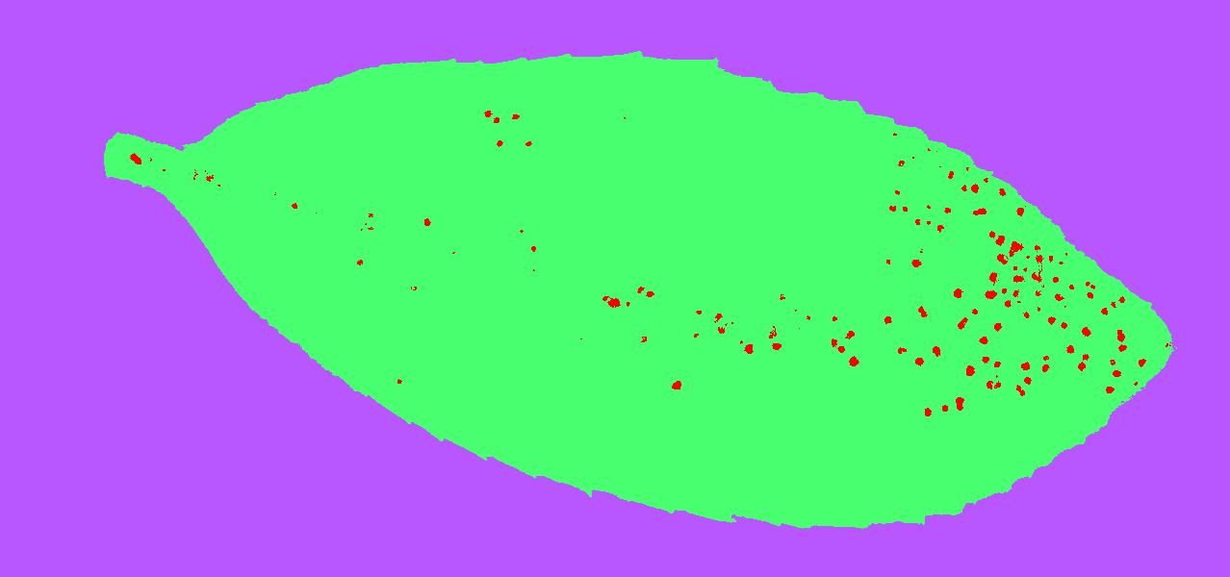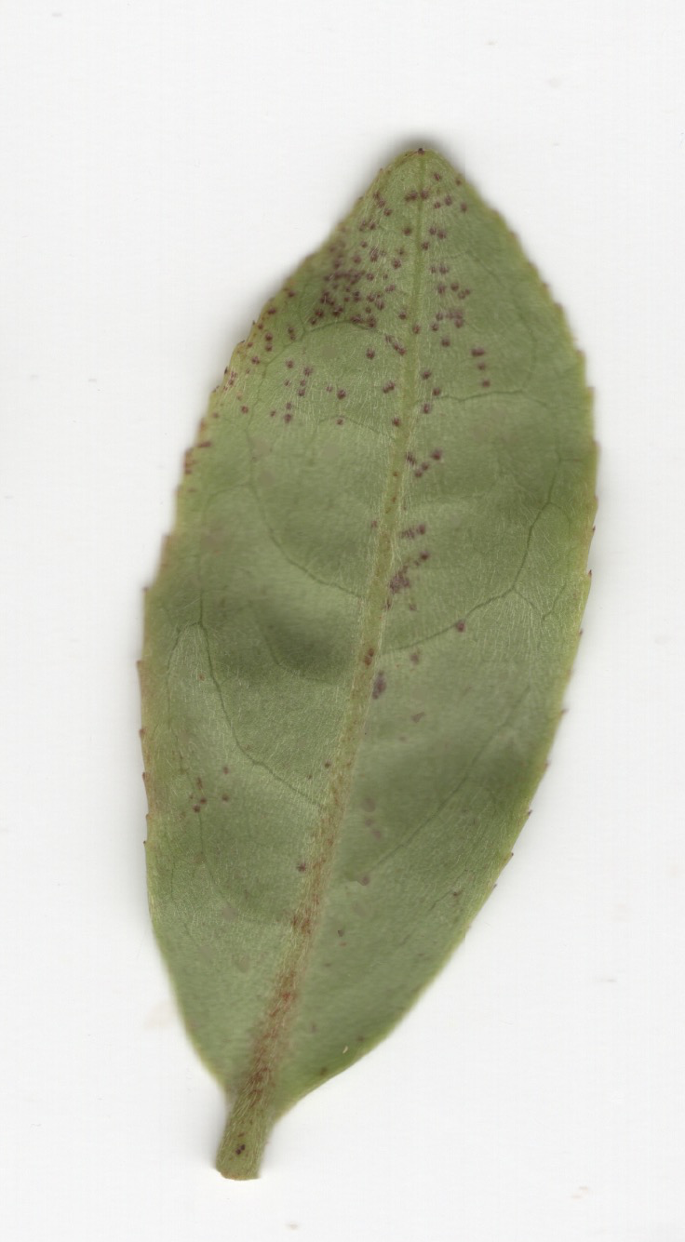

The scanner is slow, so while I am working on doing this part, it is important that the leaves don’t get too hot. Unfortunately, there is no refrigerator, so we will just turn the air conditioning on in one of the offices to make it cold.

## 5. 杀青 and drying.

Finally, after all this is done, we will use the microwave to do 杀青. There will be fewer leaves per sample for this experiment compared to the MeJA experiment, so we should be careful when using the microwave not to burn the tea leaves. Last year I would microwave 5 bags of tea at once for only 1 minute. We can then transfer the leaves to the drying machine downstairs to finish drying them.

One person can work on scanning the leaves and one person can do 杀青 and drying.